Road Safety for Runners
From Runners World

At Intersections
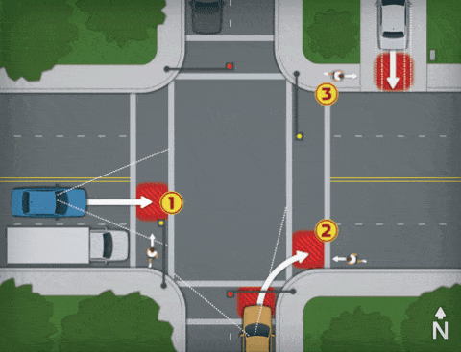
1) With the light yellow and the truck slowing to a stop, the runner moves into the crosswalk—not seeing the car blocked by the truck and rushing to beat the light. He should have waited until all vehicles were stopped at the red.
2) The driver begins to turn right on red. As he accelerates, he looks to his left for oncoming cars—but not to his right. The runner must anticipate that the driver is not looking out for him, and move to the sidewalk ASAP.
3) Using her side-and rearview mirrors to back out of the driveway, the driver fails to see the approaching runner. The runner should slow down and wait until the car backs out, or until the driver finally notices him and waves him past.

Cresting Hills

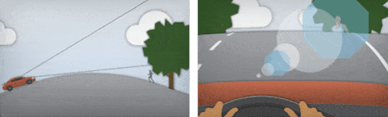
When cresting a hill, a driver's vision can suddenly be impaired by such factors as sun glare or backdrops. The runner can reduce the odds of an accident by dressing in highly visible clothing and being prepared to go off-road until she is on the other side of the hill.
On Blind Curves

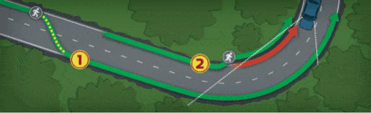
1) The runner looks to avoid surprising an unsuspecting driver. About 300 feet before the curve, he crosses to the right side of the road. When the road straightens (and traffic permits), he returns to the left side.
2) When such a crossover is impractical or unsafe, the runner should step off the road and run off-road until he's through the curve.
Illustrations by Arthur Mount

It's pitch black and you're out running. At what distance will a driver spot you? A Runner's World field-test study revealed the
best-case scenarios—as well as the worst.
1/2 MILE
Running with a headlamp or handheld light is the smartest way to make yourself visible. The whitish beam is a color that the eye sees clearly at night. And with your motion causing the light to move—the headlamp a little, the handheld a lot—a driver should recognize you as a runner.
1/4 MILE
If you don't feel comfortable wearing a headlamp or holding a flashlight, at least run with a reflective vest or a blinking red light. Drivers won't always identify you as a runner, but they'll have a hard time ignoring your motion. The light should have a bright LED (drivers see blinking red as a hazard), and the reflective material should cover half of the vest.
150 YARDS
A brightly colored jacket or top will help get a driver's attention. Yellowish green or bright orange are your best bets. Reflective panels on the sleeves can allow a driver to better detect your motion.
100 YARDS
At any distance within 100 yards, you put yourself at the mercy of a driver's reaction time. Do yourself a favor and wear clothes and shoes that have some reflective details.
50 FEET
Although a white T-shirt becomes visible before a dark one does, the difference is negligible—especially if a driver is going at a fast clip.
30-40 FEET
You're asking for trouble by running in dark pants and a dark shirt. Drivers won't notice you until they're dangerously close.

